**Sprint 4 Plan**

Product Name: Toss Time

Team Name: Sinked Inc.

Completion Date: Nov 30th, 2021

**Goal**:

To refine, and combine, multiple aspects of the project into a fully functional prototype in-line with the Minimum Viable Product.

**Task Listing**

“As a player I want a clean and smooth app experience when I login and logout of the Toss Time app”

( 10 points )

☐ Task A1 : Keyboard needs to go away when done typing (2 points)

☐ Task A2 : Button animations with changing states (2 points)

☐ Task A3 : Background is set to dark mode or light mode (2 points)

☐ Task A4 : Logout functionality (2 points)

☐ Task A5 : I can delete the photo of my table (2 points)

“As a table owner, I want to be able to remove my table listing”

( 3 points )

☐ Task B1 : Add a delete function to the Table form (3 points)

“As a team member, I want there to be a clean and standardized code base”

( 12 points )

☐ Task C1 : There is a standard styling guide (6 points)

☐ Task C2 : Full documentation of important code (6 points)

**Team Roles & Initial Task Assignments**

Cole Hennig - Product Owner - Tasks A1-5, C1-2

Steve Beurard - Scrum Master - Tasks A1-5, C1-2

Ryan Ahrari - Team Member - Tasks A1-5, C1-2

Anton Kozintsev - Team Member - Tasks A1-5, C1-2

Kenny Blum - Team Member - Tasks A1-5, B1, C1-2

**Sprint 4 Initial Burn-Up Chart**

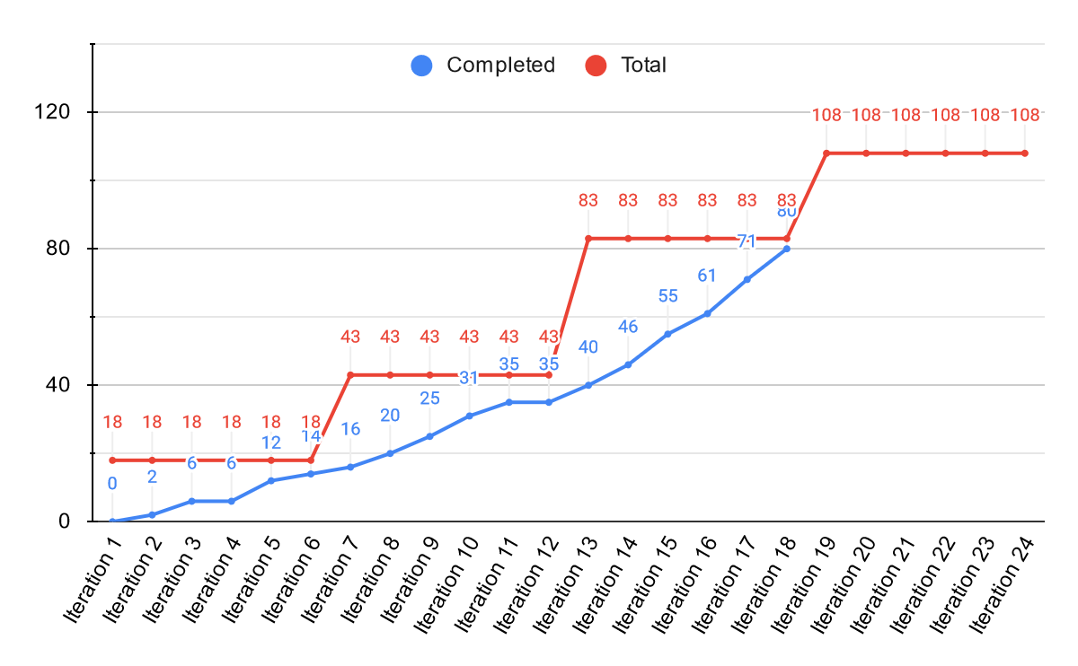

**Initial Scrum Board**

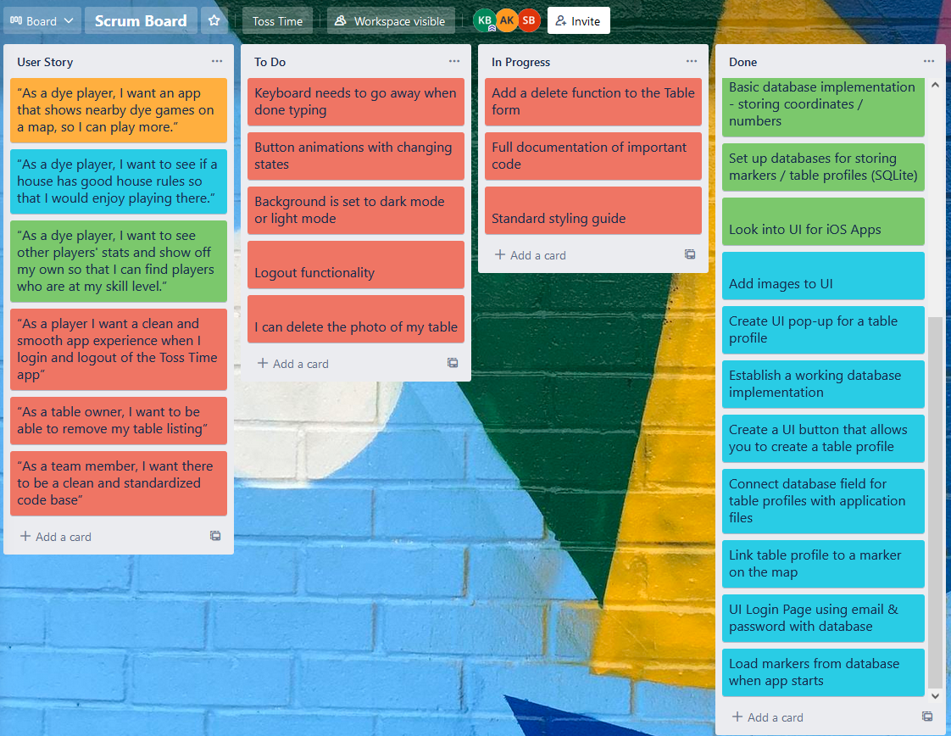

**Scrum Times**: Monday / Wednesday / Friday @ 2:30PM